Meeting Summary — Handcrafted Haven, Week 1 Date: May 19, 2026
Participants:
- Tiago Sousa
Summary:
The group held its initial project meeting to kick off the Handcrafted Haven web application. During the meeting, the project description and functional requirements were reviewed in full. The team discussed and established a design theme for the application, settling on a warm artisan aesthetic using a color palette of deep walnut, burnt sienna, warm amber, sandy linen, cream white, and sage green, paired with clean sans-serif typography.
A brainstorming session was held to identify user stories and work items for the GitHub Project Kanban board. A minimum of 10 user stories were produced, covering buyer flows (browsing, filtering, product detail, reviews, and account creation), seller flows (profiles, listings, editing, and dashboard), and system-level requirements (authentication, responsive design, and WCAG 2.1 AA accessibility).
A public GitHub repository was created for the project, a README.md file was added with the project summary and group member name, and the repository was cloned locally. Task assignments and next steps were reviewed to prepare for the following week's development sprint.
Project URL:
https://github.com/tiagorockman/WDD430-BYU-Fullstack-group-project

Evidence that the individual student created a local copy of the repo.
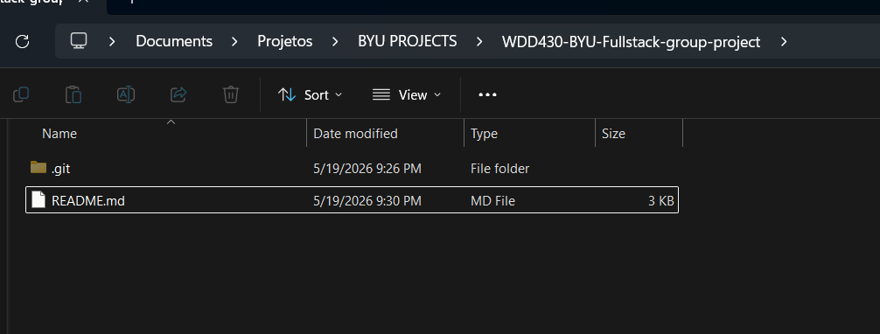

Color Schema
Name | Hex | Usage
Deep Walnut | #3B2314 | Navbar background, headings, primary text
Burnt Sienna | #7A4019 | Primary buttons, prices, accent text
Warm Amber | #C9813A | Star ratings, highlights, hover states
Sandy Linen | #E8C99A | Borders, subtle backgrounds, card accents
Cream White | #FDF8F3 | Page background, card surfaces
Sage Green | #4A7C59 | "Handmade" badge, success states, accents

A list of at least 10 work items needed for the group project.

# | Title | Description
1 | Set up Next.js project | Initialize the Next.js app with Tailwind CSS, configure folder structure, and deploy a base build to Vercel.
2 | Configure GitHub repository & Kanban board | Create the public repo, set up GitHub Projects with To Do / In Progress / Done columns, and invite collaborators.
3 | Design global UI theme | Implement the color palette, typography, and reusable component styles (buttons, badges, cards) in Tailwind config.
4 | Build navigation & layout | Create the site-wide header, footer, and responsive navigation that collapses to a hamburger menu on mobile.
5 | User authentication | Implement register, login, and logout functionality with session or JWT-based auth and protected routes.
6 | Seller profile page | Build the seller profile page displaying avatar, bio, location, and a grid of that seller's listed products.
7 | Product listing form | Create the form that allows authenticated sellers to add a new product with title, description, category, price, quantity, and images.
8 | Product catalog page | Build the browsable product grid with pagination, category filters, price range filter, and keyword search.
9 | Product detail page | Create the individual product page showing image gallery, full description, seller info, price, and customer reviews.
10 | Reviews & ratings system | Allow any authenticated user to submit a 1–5 star rating and written review on a product, displayed with username and date.
11 | Seller dashboard | Build a protected dashboard where sellers can view, edit, and delete their listings and see their average rating.
12 | Accessibility & responsive audit | Run Lighthouse audits on all pages, fix contrast issues, add missing alt text and ARIA labels to meet WCAG 2.1 AA.

